**School Analysis:**

# District Summary:

Original:

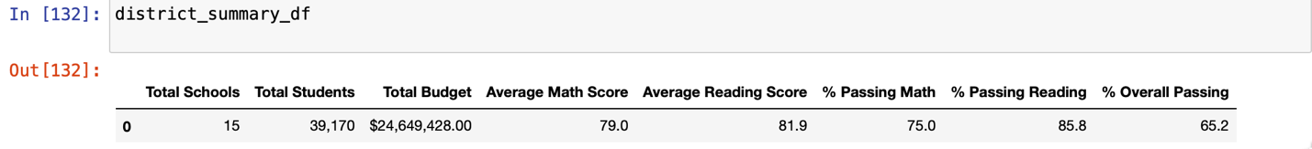

Modified:

#School Summary:

Original:

Modified:

#Replacing 9th Graders School Rankings:

Original:

Modified:

# Math and Reading Scores by Grade:

Math:

Reading:

# Scores by Spending:

Original:

Modified:

# Scores by School Size:

Original:

Modified:

# Scores by School Type:

Original:

Modified:

